Name : Mansuri Soharab Tajmohammad
Roll no.: 86
Subject : Full Stack Development
FSD Final Project

Project Name : HabitGuard

Definition
HabitGuard is a full-stack web application developed to help users track their daily habits and analyze their performance over time.
It is built using React for the frontend and Node.js with Express.js for the backend, with data stored in MongoDB.
The system provides features like streak tracking, behavior validation, and smart suggestions to improve user productivity.
The application is deployed using Render (backend) and Netlify (frontend).

Scope
The scope of this project includes designing and developing a web-based system for managing and analyzing daily habits.
It helps users monitor their routine, track consistency, and improve productivity through insights and feedback.
The system can be extended with advanced features like authentication, notifications, and analytics dashboards.
It can be applied in domains such as personal productivity, education, and health management.

Objective
- To develop a full-stack web application for tracking daily habits
- To analyze user behavior and calculate streaks and consistency
- To detect suspicious or unrealistic user activity patterns
- To provide smart suggestions for improving habits
- To deploy the application using cloud platforms for accessibility

Features
- Add, update, and delete habits
- Mark habits as completed daily
- Streak and consistency tracking
- Behavior validation to detect suspicious activity
- Smart suggestions based on user performance
- Goal setting (timer-based habits)
- Reminder and date selection features
- Habit categorization and filtering
- Activity history and insights
- User-friendly interface with online access

Screenshots
Hosted using Netlify (Frontend):
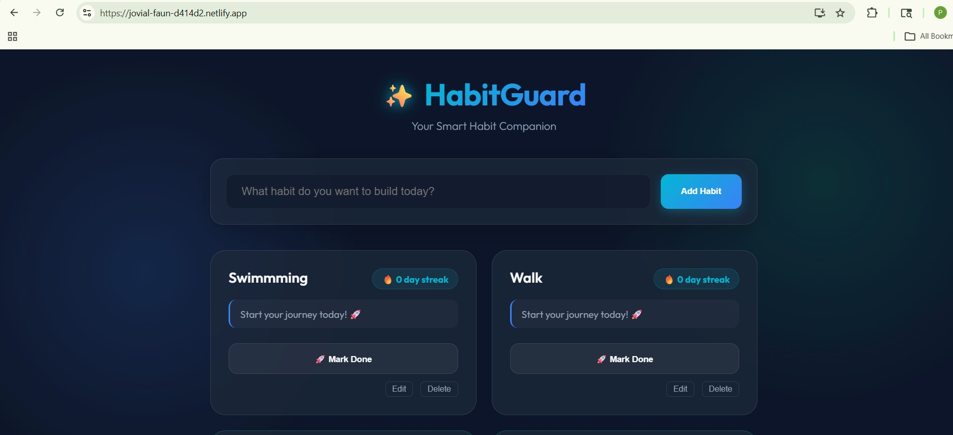
Backend using MongoDB Atlas & Render:
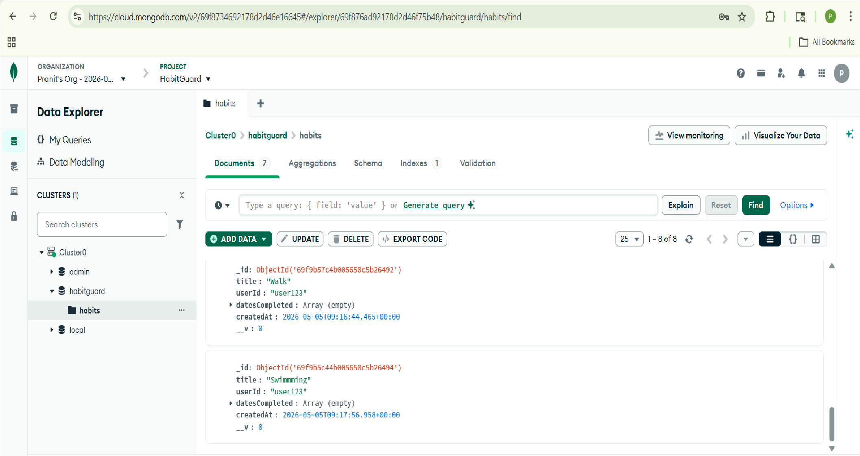
Without Host
Frontend
Language: Javascript Library: React.js http://localhost:3001/
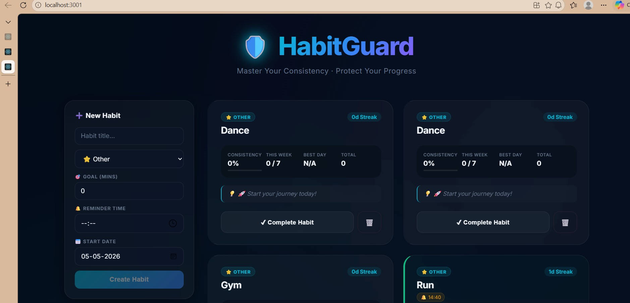
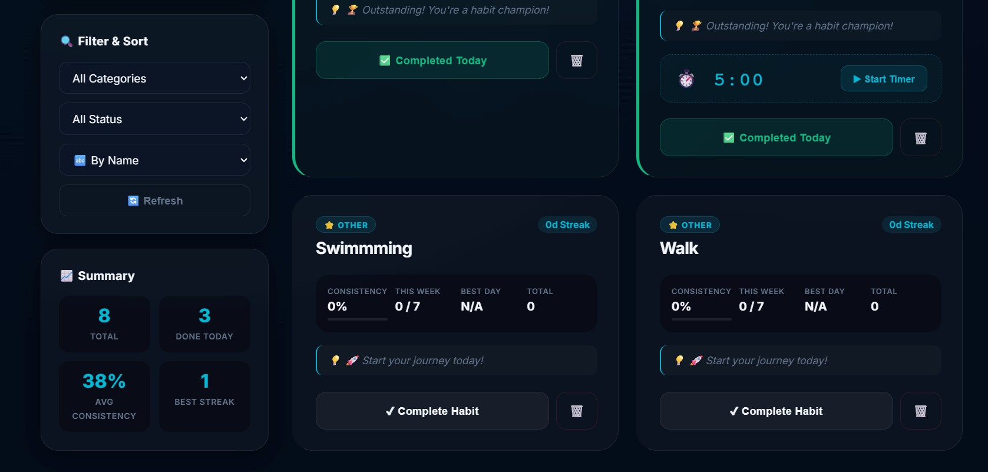
Backend
Language: JavaScript Environment: Node.js
Framework: Express.js
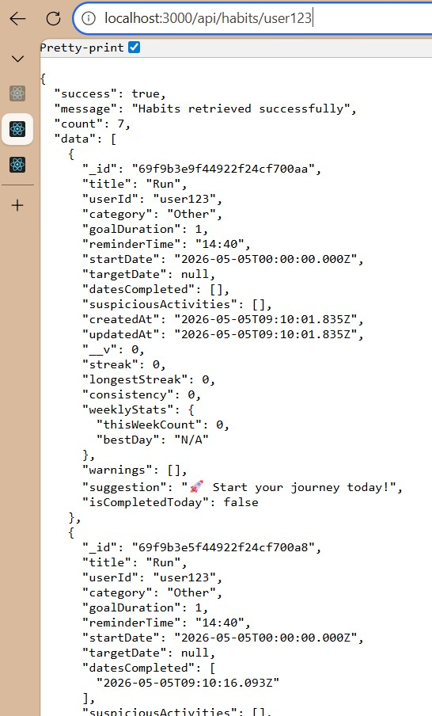
localhost:3000/api/habits/user123

